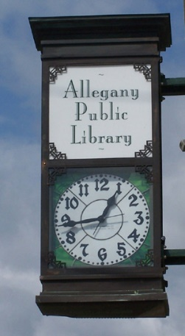

1,555 Registered Users

450 Village Users

674 Town Users

7,255 Total Library Visits

1,821 Computer Sessions

778 WiFi Sessions

1,119 Reference Q&As

Join us Summer 2024 for

“Adventure Begins at

Your Library” Summer

Reading Program!

Activities and Prizes!

Ages Pre-K to Age 12!

***Library Services:***

Public computers

Fax/Printing Access

Children’s Programs

Interlibrary Loans

Free WiFi

Magazines, Local Newspapers

2,205 Adult books borrowed

1,924 Children’s books borrowed

1,168 Other Items Borrowed

2,130 Electronic Materials borrowed

34, 808 Printed Books

22,380 Ebooks Available

3,415 Movies on BluRay and DVD

1,596 Downloadable Movies

375 Audio Books on CD

8,683 Downloadable Audio Books

**Allegany Public Library**

**90 West Main St.**

**Allegany, NY 14706**

**716-373-1056**

**Monday-Friday: 10-6pm**

**www.alleganylibrary.org**

***2023 Annual Report for the Community***