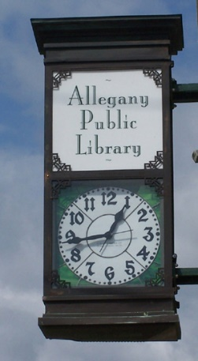

***Library Services:***

Public computers

Fax/Printing Access

Children’s Programs

Interlibrary Loans

Free WiFi

Books, E-books, DVDS

Music CDS, Audiobooks

Magazines, Local Newspaper

**1903 Adult books borrowed**

**1756 Children’s books borrowed**

**1785 Electronic Materials borrowed**

**1387 VHS & CDS Borrowed**

**7523 Library visitors**

**10,354 Computer users**

**1487 Registered Users**

**(Population Charted to Served 1,816)**

**Allegany Public Library**

**90 West Main St.**

**Allegany, NY 14706**

**716-373-1056**

**Monday-Friday: 10-6pm**

**Saturday 10-1pm (except summer)**

**www.alleganylibrary.org**

***2022 Annual Report for the Community***

2022 was the year that the Allegany Public Library underwent a remarkable transformation. The once traditional brick-and-mortar institution embraced a digital revolution, redefining the way the community accessed knowledge and services.

In response to the ever-evolving needs of its patrons, the library embarked on a bold journey into the digital realm.”

We really like ebooks and videogames.