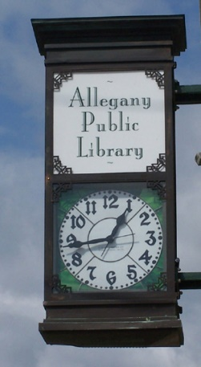

***Library Services:***

Public computers

Fax/Printing Access

Children’s Programs

Interlibrary Loans

Free WiFi

Books, E-books, DVDS

Music CDS, Audiobooks

Magazines, Local Newspaper

**1621 Adult books borrowed**

**1683 Children’s books borrowed**

**1432 Electronic Materials borrowed**

**1485 DVDS & CDS Borrowed**

**3843 Library visitors**

**1561 Computer users**

**1325 Registered Users**

**(Population Charted to Served 1,816)**

**Allegany Public Library**

**90 West Main St.**

**Allegany, NY 14706**

**716-373-1056**

**Monday-Friday: 10-6pm**

**Saturday 10-1pm (closed June1st-August 31st)**

**www.alleganylibrary.org**

***2020 Annual Report for the Community***

During the 2020 pandemic the library was closed for three months. During this time, our staff was staying safe and healthy at home with their families. In June, the library was able to reopen for curbside pickup with limited staff available at the library. Cleaning and reopening procedures were being worked on at this time. In July, we were able to have our staff back to their regular schedule but with limited capacity for patrons along with computer and other resources limited. Over the next few months, resources and capacities began to get lifted. The library staff continues to practice safe cleaning procedures.